

**OSPF Area Types**

**Lab Documentation**

Ryan Chen

9/13/2023

**Purpose:**

The primary purpose of this lab was to learn and distinguish the differences between the various OSPF area types, namely normal area, stub area, totally stubby area, and not-so-stubby area. To do so, we needed to research and identify the different OSPF LSA types in order to compare the differences between area types.

**Background Information:**

OSPF is a network routing protocol that allows the various routers in a large network to easily exchange information amongst each other. OSPF is primarily used to distribute the shortest route that it takes to get to each router in a network. Routes can be thought of as physical directions to another router. Analogous to how a person would use a map to navigate to a destination, routers use distributed OSPF route information to know where to send their information based on a destination. All routers using OSPF must initialize the process, upon which the network must be initialized before routes can be sent. Each router subsequently distributes all their known routes to their neighbors, allowing the entire network to be connected.

OSPF areas are used in order to separate a large OSPF network into multiple subdomains. Their primary purpose is to organize and manage the various subnetworks for routing in a larger scale network. Each type of area accepts different OSPF Link State Advertisement (LSA) packets, which are necessary for OSPF to function. LSA packets are used in order to fill the database of each OSPF router with routing information about the network. Type 1-3 of OSPF LSA’s are primarily used for backbone/standard OSPF routing, and they provide basic information about routes and network topology. Type 4 LSA’s are used in networks that have a connection to a non OSPF network. They are broadcasted by each Area Border Router (ABR, connected between OSPF areas) with information about where to find the Autonomous System Border Router (ASBR, connected to non OSPF). Type 5 LSA’s include the non OSPF network information, allowing OSPF networks to connect to routing protocols such as RIP, EIGRP, and ISIS. Finally, Type 7 LSA’s are used exclusively in NSSA areas, which will be introduced later.

Basic OSPF runs in the backbone area, or otherwise known as Area 0. This is what smaller networks utilize for their routing. In larger multiarea networks, all areas must be connected to this backbone network in order to guarantee connectivity. Aside from the backbone area, different standard OSPF areas can be created which function like the backbone.

In our lab, we utilized stub areas, which do not accept any external routes in the network. However, stub areas still allow internal area routes, meaning routers in the same stub area can communicate with each other. In order to communicate with any external areas, stub areas use a default route to a single ABR which then handles interarea routing. Stub areas block all Type 5 and Type 7 LSA’s, which reduces CPU/RAM usage and database size, allowing for faster performance on large networks.

A variant of the stub areas is the totally stubby area, which likewise blocks any external routes but also removes the propagation of any internal routes. In a totally stubby area, all routers rely on an injected default route that points traffic to their ABR, which then handles routing. Totally stubby areas block Type 5, 7, and 3 LSA’s, which improves performance even further.

Finally, not-so-stubby areas are stub areas that include an ASBR which allows for non-OSPF connected routers and routes to be advertised into the area. The area does this by converting special external Type 7 LSA’s into Type 5 LSA’s to be advertised into the network. This allows completely external networks to be connected to an OSPF network.

**Lab Summary:**

In this lab, our objective was to setup the various OSPF area types, analyze how they work, and understand when/why to use them. To begin, we handwrote out topology with the various OSPF area types, adding interfaces and subnetting the network. After this, we transferred our diagram to Packet Tracer and began to build our network.

The process of building the topology with the different area types was quite simple, as OSPF stub configuration only requires a few additional commands. Our topology consisted of a central backbone area that all other areas connected to. At first, we wanted to connect all three backbone routers together, but quickly realized that the limitation of only having two gigabit ports per router meant we needed a switch in order to connect all three. Inside our lab, we used the 10.x.x.x subnet, incrementing for each area. Routers were given IPs based on their number.

For stub and totally stubby areas, we had a single ABR and a router which simulated the area. However, for our NSSA, we decided to configure our ASBR using a Loopback interface that was configured with EIGRP, allowing us to simulate a fully external network without using another router.

summAfter successfully configuring all the area types, we moved onto analyzing how each area worked. To do so, we needed to intercept traffic between each OSPF router, which was achieved by connected a switch and enabling session monitoring. Session monitoring the switch allowed us to forward all the traffic through our port. Using Wireshark, we could analyze all OSPF LSA types to understand the functions of each area type.

**Lab Commands:**

area [area-id] stub

-Configures an OSPF area into stub

area [area-id] stub no-summary

-Configures an OSPF area into totally stubby on the ABR

area [area-id] nssa

-Configures an OSPF area into NSSA

monitor session [session #] source interface [source interface]

monitor session [session #] destination interface [destination interface]

-Used to forward all traffic to an interface for Wireshark capture

**Network Diagram and IP Table:**

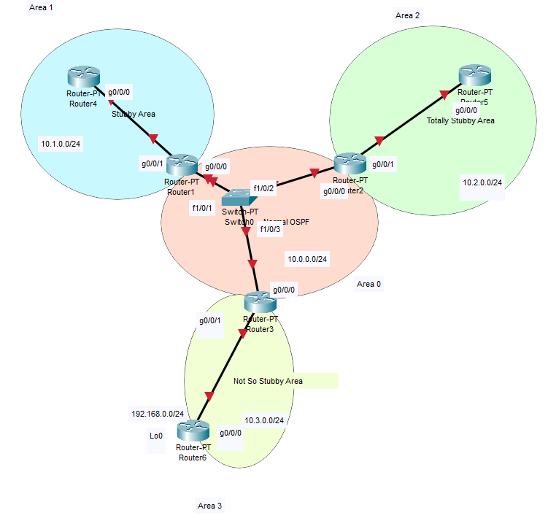

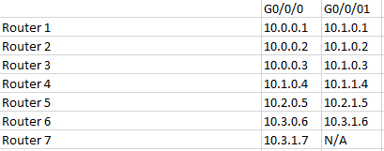

**Configurations and Routes:**

**R1**

hostname R1

boot-start-marker

boot-end-marker

vrf definition Mgmt-intf

address-family ipv4

exit-address-family

address-family ipv6

exit-address-family

no aaa new-model

subscriber templating

multilink bundle-name authenticated

license udi pid ISR4321/K9 sn FDO21491LXV

license accept end user agreement

license boot level securityk9

spanning-tree extend system-id

redundancy

mode none

interface GigabitEthernet0/0/0

ip address 10.0.0.1 255.255.255.0

ip ospf 1 area 0

no shutdown

negotiation auto

interface GigabitEthernet0/0/1

ip address 10.1.0.1 255.255.255.0

ip ospf 1 area 1

no shutdown

negotiation auto

interface Serial0/1/0

no ip address

shutdown

interface Serial0/1/1

no ip address

shutdown

interface GigabitEthernet0

vrf forwarding Mgmt-intf

no ip address

shutdown

negotiation auto

interface Vlan1

no ip address

shutdown

router ospf 1

router-id 1.1.1.1

area 1 stub

network 10.0.0.0 0.0.255.255 area 0

network 10.1.0.0 0.0.255.255 area 1

ip forward-protocol nd

no ip http server

no ip http secure-server

ip tftp source-interface GigabitEthernet0

control-plane

line con 0

stopbits 1

line aux 0

stopbits 1

line vty 0 4

login

end

R1#show ip route

Codes: L - local, C - connected, S - static, R - RIP, M - mobile, B - BGP

D - EIGRP, EX - EIGRP external, O - OSPF, IA - OSPF inter area

N1 - OSPF NSSA external type 1, N2 - OSPF NSSA external type 2

E1 - OSPF external type 1, E2 - OSPF external type 2

i - IS-IS, su - IS-IS summary, L1 - IS-IS level-1, L2 - IS-IS level-2

ia - IS-IS inter area, * - candidate default, U - per-user static route

o - ODR, P - periodic downloaded static route, H - NHRP, l - LISP

a - application route

+ - replicated route, % - next hop override, p - overrides from PfR

Gateway of last resort is not set

10.0.0.0/8 is variably subnetted, 6 subnets, 2 masks

C 10.0.0.0/24 is directly connected, GigabitEthernet0/0/0

L 10.0.0.1/32 is directly connected, GigabitEthernet0/0/0

C 10.1.0.0/24 is directly connected, GigabitEthernet0/0/1

L 10.1.0.1/32 is directly connected, GigabitEthernet0/0/1

O IA 10.2.0.0/24 [110/2] via 10.0.0.2, 00:09:26, GigabitEthernet0/0/0

O IA 10.3.0.0/24 [110/2] via 10.0.0.3, 00:19:40, GigabitEthernet0/0/0

O E2 192.168.0.0/24 [110/20] via 10.0.0.3, 00:18:35, GigabitEthernet0/0/0

**R2**

hostname R2

boot-start-marker

boot-end-marker

vrf definition Mgmt-intf

address-family ipv4

exit-address-family

address-family ipv6

exit-address-family

no aaa new-model

subscriber templating

multilink bundle-name authenticated

license udi pid ISR4321/K9 sn FDO214420QQ

license accept end user agreement

license boot level securityk9

spanning-tree extend system-id

redundancy

mode none

interface GigabitEthernet0/0/0

ip address 10.0.0.2 255.255.255.0

ip ospf 1 area 0

no shutdown

negotiation auto

interface GigabitEthernet0/0/1

ip address 10.2.0.2 255.255.255.0

ip ospf 1 area 2

no shutdown

negotiation auto

interface Serial0/1/0

no ip address

shutdown

interface Serial0/1/1

no ip address

shutdown

interface GigabitEthernet0

vrf forwarding Mgmt-intf

no ip address

shutdown

negotiation auto

interface Vlan1

no ip address

shutdown

router ospf 1

router-id 2.2.2.2

network 10.0.0.0 0.0.255.255 area 0

network 10.2.0.0 0.0.255.255 area 2

area 2 stub no-summary

ip forward-protocol nd

no ip http server

no ip http secure-server

ip tftp source-interface GigabitEthernet0

control-plane

line con 0

stopbits 1

line aux 0

stopbits 1

line vty 0 4

login

end

R2#show ip route

Codes: L - local, C - connected, S - static, R - RIP, M - mobile, B - BGP

D - EIGRP, EX - EIGRP external, O - OSPF, IA - OSPF inter area

N1 - OSPF NSSA external type 1, N2 - OSPF NSSA external type 2

E1 - OSPF external type 1, E2 - OSPF external type 2

i - IS-IS, su - IS-IS summary, L1 - IS-IS level-1, L2 - IS-IS level-2

ia - IS-IS inter area, * - candidate default, U - per-user static route

o - ODR, P - periodic downloaded static route, H - NHRP, l - LISP

a - application route

+ - replicated route, % - next hop override, p - overrides from PfR

Gateway of last resort is not set

10.0.0.0/8 is variably subnetted, 6 subnets, 2 masks

C 10.0.0.0/24 is directly connected, GigabitEthernet0/0/0

L 10.0.0.2/32 is directly connected, GigabitEthernet0/0/0

O IA 10.1.0.0/24 [110/2] via 10.0.0.1, 00:01:54, GigabitEthernet0/0/0

C 10.2.0.0/24 is directly connected, GigabitEthernet0/0/1

L 10.2.0.2/32 is directly connected, GigabitEthernet0/0/1

O IA 10.3.0.0/24 [110/2] via 10.0.0.3, 00:01:54, GigabitEthernet0/0/0

O E2 192.168.0.0/24 [110/20] via 10.0.0.3, 00:01:54, GigabitEthernet0/0/0

**R3**

hostname R3

boot-start-marker

boot-end-marker

vrf definition Mgmt-intf

address-family ipv4

exit-address-family

address-family ipv6

exit-address-family

no aaa new-model

subscriber templating

vtp domain cisco

vtp mode transparent

multilink bundle-name authenticated

license udi pid ISR4321/K9 sn FDO214420HY

license boot level securityk9

spanning-tree extend system-id

redundancy

mode none

interface GigabitEthernet0/0/0

ip address 10.0.0.3 255.255.255.0

ip ospf 1 area 0

no shutdown

negotiation auto

interface GigabitEthernet0/0/1

ip address 10.3.0.3 255.255.255.0

ip ospf 1 area 3

no shutdown

negotiation auto

interface Serial0/1/0

no ip address

interface Serial0/1/1

no ip address

interface GigabitEthernet0

vrf forwarding Mgmt-intf

no ip address

negotiation auto

interface Vlan1

no ip address

router ospf 1

router-id 3.3.3.3

network 10.0.0.0 0.0.255.255 area 0

network 10.3.0.0 0.0.255.255 area 3

area 3 nssa

ip forward-protocol nd

no ip http server

no ip http secure-server

control-plane

line con 0

stopbits 1

line aux 0

stopbits 1

line vty 0 4

login

end

R3#show ip route

Codes: L - local, C - connected, S - static, R - RIP, M - mobile, B - BGP

D - EIGRP, EX - EIGRP external, O - OSPF, IA - OSPF inter area

N1 - OSPF NSSA external type 1, N2 - OSPF NSSA external type 2

E1 - OSPF external type 1, E2 - OSPF external type 2

i - IS-IS, su - IS-IS summary, L1 - IS-IS level-1, L2 - IS-IS level-2

ia - IS-IS inter area, * - candidate default, U - per-user static route

o - ODR, P - periodic downloaded static route, H - NHRP, l - LISP

a - application route

+ - replicated route, % - next hop override, p - overrides from PfR

Gateway of last resort is not set

10.0.0.0/8 is variably subnetted, 6 subnets, 2 masks

C 10.0.0.0/24 is directly connected, GigabitEthernet0/0/0

L 10.0.0.3/32 is directly connected, GigabitEthernet0/0/0

O IA 10.1.0.0/24 [110/2] via 10.0.0.1, 00:20:38, GigabitEthernet0/0/0

O IA 10.2.0.0/24 [110/2] via 10.0.0.2, 00:10:14, GigabitEthernet0/0/0

C 10.3.0.0/24 is directly connected, GigabitEthernet0/0/1

L 10.3.0.3/32 is directly connected, GigabitEthernet0/0/1

O N2 192.168.0.0/24 [110/20] via 10.3.0.6, 00:19:24, GigabitEthernet0/0/1

**R4**

hostname R4

boot-start-marker

boot-end-marker

vrf definition Mgmt-intf

address-family ipv4

exit-address-family

address-family ipv6

exit-address-family

no aaa new-model

subscriber templating

vtp domain cisco

vtp mode transparent

multilink bundle-name authenticated

license udi pid ISR4321/K9 sn FDO214333H6

license boot level securityk9

spanning-tree extend system-id

redundancy

mode none

interface GigabitEthernet0/0/0

ip address 10.1.0.4 255.255.255.0

ip ospf 1 area 1

negotiation auto

no shutdown

interface GigabitEthernet0/0/1

no ip address

shutdown

negotiation auto

interface Serial0/1/0

no ip address

shutdown

interface Serial0/1/1

no ip address

shutdown

interface GigabitEthernet0

vrf forwarding Mgmt-intf

no ip address

shutdown

negotiation auto

interface Vlan1

no ip address

shutdown

router ospf 1

router-id 4.4.4.4

area 1 stub

network 10.1.0.0 0.0.0.255 area 1

ip forward-protocol nd

no ip http server

no ip http secure-server

ip tftp source-interface GigabitEthernet0

control-plane

line con 0

stopbits 1

line aux 0

stopbits 1

line vty 0 4

login

end

R4#show ip route

Codes: L - local, C - connected, S - static, R - RIP, M - mobile, B - BGP

D - EIGRP, EX - EIGRP external, O - OSPF, IA - OSPF inter area

N1 - OSPF NSSA external type 1, N2 - OSPF NSSA external type 2

E1 - OSPF external type 1, E2 - OSPF external type 2

i - IS-IS, su - IS-IS summary, L1 - IS-IS level-1, L2 - IS-IS level-2

ia - IS-IS inter area, * - candidate default, U - per-user static route

o - ODR, P - periodic downloaded static route, H - NHRP, l - LISP

a - application route

+ - replicated route, % - next hop override, p - overrides from PfR

Gateway of last resort is 10.1.0.1 to network 0.0.0.0

O*IA 0.0.0.0/0 [110/2] via 10.1.0.1, 00:32:40, GigabitEthernet0/0/0

10.0.0.0/8 is variably subnetted, 5 subnets, 2 masks

O IA 10.0.0.0/24 [110/2] via 10.1.0.1, 00:32:40, GigabitEthernet0/0/0

C 10.1.0.0/24 is directly connected, GigabitEthernet0/0/0

L 10.1.0.4/32 is directly connected, GigabitEthernet0/0/0

O IA 10.2.0.0/24 [110/3] via 10.1.0.1, 00:11:25, GigabitEthernet0/0/0

O IA 10.3.0.0/24 [110/3] via 10.1.0.1, 00:21:39, GigabitEthernet0/0/0

**R5**

hostname R5

boot-start-marker

boot-end-marker

vrf definition Mgmt-intf

address-family ipv4

exit-address-family

address-family ipv6

exit-address-family

no aaa new-model

subscriber templating

vtp domain cisco

vtp mode transparent

multilink bundle-name authenticated

license udi pid ISR4321/K9 sn FDO21482HYV

spanning-tree extend system-id

redundancy

mode none

interface GigabitEthernet0/0/0

ip address 10.2.0.5 255.255.255.0

negotiation auto

no shutdown

interface GigabitEthernet0/0/1

no ip address

shutdown

negotiation auto

interface Serial0/1/0

no ip address

shutdown

interface Serial0/1/1

no ip address

shutdown

interface GigabitEthernet0/2/0

no ip address

shutdown

negotiation auto

interface GigabitEthernet0/2/1

no ip address

shutdown

negotiation auto

interface GigabitEthernet0

vrf forwarding Mgmt-intf

no ip address

shutdown

negotiation auto

interface Vlan1

no ip address

shutdown

router ospf 1

router-id 5.5.5.5

area 2 stub

network 10.2.0.0 0.0.0.255 area 2

ip forward-protocol nd

no ip http server

no ip http secure-server

ip tftp source-interface GigabitEthernet0

control-plane

line con 0

stopbits 1

line aux 0

stopbits 1

line vty 0 4

login

end

R5#show ip route

Codes: L - local, C - connected, S - static, R - RIP, M - mobile, B - BGP

D - EIGRP, EX - EIGRP external, O - OSPF, IA - OSPF inter area

N1 - OSPF NSSA external type 1, N2 - OSPF NSSA external type 2

E1 - OSPF external type 1, E2 - OSPF external type 2

i - IS-IS, su - IS-IS summary, L1 - IS-IS level-1, L2 - IS-IS level-2

ia - IS-IS inter area, * - candidate default, U - per-user static route

o - ODR, P - periodic downloaded static route, H - NHRP, l - LISP

a - application route

+ - replicated route, % - next hop override, p - overrides from PfR

Gateway of last resort is 10.2.0.2 to network 0.0.0.0

O*IA 0.0.0.0/0 [110/2] via 10.2.0.2, 00:02:24, GigabitEthernet0/0/0

10.0.0.0/8 is variably subnetted, 2 subnets, 2 masks

C 10.2.0.0/24 is directly connected, GigabitEthernet0/0/0

L 10.2.0.5/32 is directly connected, GigabitEthernet0/0/0

**R6**

hostname R6

boot-start-marker

boot-end-marker

vrf definition Mgmt-intf

address-family ipv4

exit-address-family

address-family ipv6

exit-address-family

no aaa new-model

subscriber templating

vtp domain cisco

vtp mode transparent

multilink bundle-name authenticated

license udi pid ISR4321/K9 sn FDO214913GF

spanning-tree extend system-id

redundancy

mode none

vlan internal allocation policy ascending

interface Loopback0

ip address 192.168.0.1 255.255.255.0

interface GigabitEthernet0/0/0

ip address 10.3.0.6 255.255.255.0

negotiation auto

interface GigabitEthernet0/0/1

ip address 10.3.1.6 255.255.255.0

negotiation auto

interface Serial0/1/0

no ip address

shutdown

interface Serial0/1/1

no ip address

shutdown

interface GigabitEthernet0/2/0

no ip address

shutdown

negotiation auto

interface GigabitEthernet0/2/1

no ip address

shutdown

negotiation auto

interface GigabitEthernet0

vrf forwarding Mgmt-intf

no ip address

shutdown

negotiation auto

interface Vlan1

no ip address

shutdown

router eigrp 1

network 192.168.0.0

redistribute connected

router ospf 1

router-id 6.6.6.6

area 3 nssa

redistribute connected subnets

network 10.3.0.0 0.0.255.255 area 3

ip forward-protocol nd

no ip http server

no ip http secure-server

ip tftp source-interface GigabitEthernet0

control-plane

line con 0

stopbits 1

line aux 0

stopbits 1

line vty 0 4

login

end

R6#show ip route

Codes: L - local, C - connected, S - static, R - RIP, M - mobile, B - BGP

D - EIGRP, EX - EIGRP external, O - OSPF, IA - OSPF inter area

N1 - OSPF NSSA external type 1, N2 - OSPF NSSA external type 2

E1 - OSPF external type 1, E2 - OSPF external type 2

i - IS-IS, su - IS-IS summary, L1 - IS-IS level-1, L2 - IS-IS level-2

ia - IS-IS inter area, * - candidate default, U - per-user static route

o - ODR, P - periodic downloaded static route, H - NHRP, l - LISP

a - application route

+ - replicated route, % - next hop override, p - overrides from PfR

Gateway of last resort is not set

10.0.0.0/8 is variably subnetted, 5 subnets, 2 masks

O IA 10.0.0.0/24 [110/2] via 10.3.0.3, 00:19:47, GigabitEthernet0/0/0

O IA 10.1.0.0/24 [110/3] via 10.3.0.3, 00:19:47, GigabitEthernet0/0/0

O IA 10.2.0.0/24 [110/3] via 10.3.0.3, 00:10:37, GigabitEthernet0/0/0

C 10.3.0.0/24 is directly connected, GigabitEthernet0/0/0

L 10.3.0.6/32 is directly connected, GigabitEthernet0/0/0

192.168.0.0/24 is variably subnetted, 2 subnets, 2 masks

C 192.168.0.0/24 is directly connected, Loopback0

L 192.168.0.1/32 is directly connected, Loopback0

**LSA Types:**

**Type 1:**

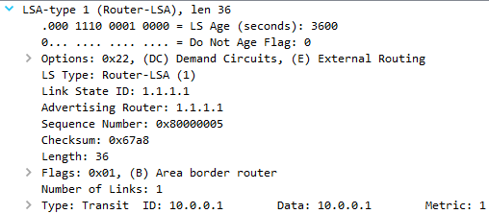

**Type 2:**

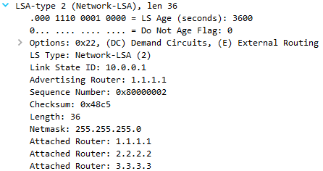

**Type 3:**

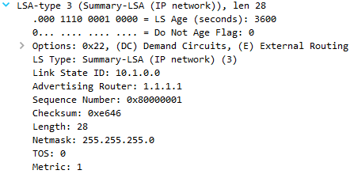

**Type 4:**

c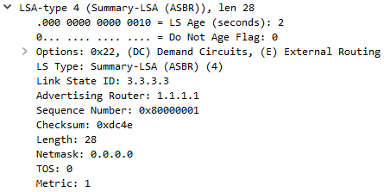

**Type 5:**

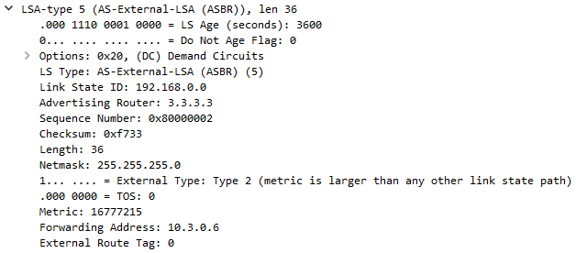

**Type 7:**

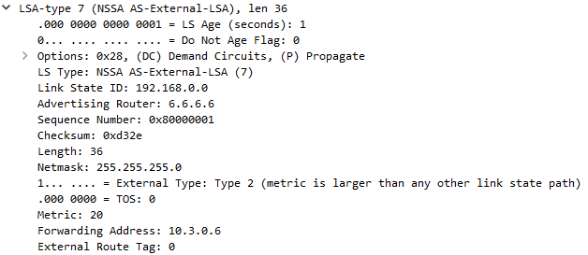

**Problems:**

-When we were making our topology, we initially planned to directly connect all three routers in our backbone area, but quickly realized that it would not be possible because each router only had two gigabit ports

-To fix this, we connected all the routers in the backbone to a Type 2 switch

-Upon configuring NSSA, we initially wanted to use a seventh router, but external route propagation didn’t work

-To fix this, we decided to eliminate the seventh router and instead configure EIGRP on the loopback to simplify the topology

-When monitoring packets at first, we kept getting OSPF area mismatch errors but pings worked

-Later realized that the switch was connected to another device that was sending packets, causing OSPF to not recognize it, so we fixed it by disconnected the device

-We weren’t able to get all the OSPF updates, especially type 4 and type 7 packets even after connected switch as an intermediary device

-To fix this, we had to use session monitoring to forward all traffic sent through the switch, which showed us the complete LSA types

**Conclusion:**

This lab taught us the importance of troubleshooting skills alongside what the different OSPF area types are and how to configure them. When we were making the topology, we realized the switch issue, and later on had the annoying problem of mismatching area IDs. To troubleshoot these, we made sure to go through all possible issues and eventually was able to fix it. As for OSPF area types, stubby and totally stubby provide a more efficient OSPF alternate. Wireshark can be used for packet analysis and was a crucial part in this lab as well.

OSPF Types Signoff Sheet

Ryan Chen, P3-4 Cisco CCNP, Mr. Mason

